

Programming Fundamentals

Assignment No 6

Student Name :MOMIN HAYAT KHAN

Roll No: S20-0273

Department :BS(Artificial Intelligence)

Batch / Year:SPRING 2020

Lecturer: Mam Misbah

Assignment No 6

Program No 1:

|  |
| --- |
| #include <cmath> // defines the sqrt() function  #include <iostream>  using namespace std;  int main()  { // tests the sqrt() function:  for (int x=0; x <=9; x++)  cout << "\t" << x << "\t" <<sqrt(x)<<endl;} |

Output:

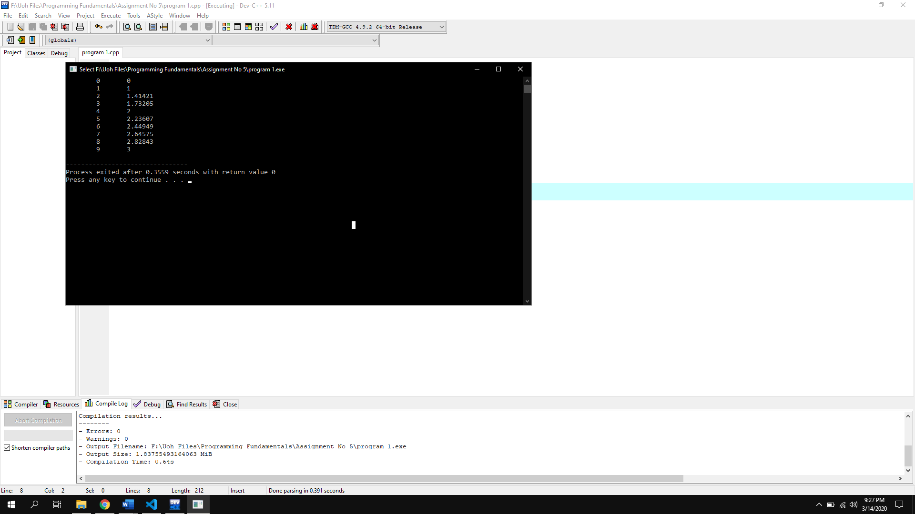

Types of Function:

|  |
| --- |
| There are two types of functions.   * User Defined function. * Pre Defined function. |

Syntax Of function (Prototype, call & body of function):

|  |
| --- |
| // Create a function void myFunction() {   cout << "I just got executed!"; }  int main() {   **myFunction();** // call the function   return 0;} |

Program No 2:

|  |
| --- |
| #include <iostream>  using namespace std;  void sqr(int a){  cout<<a*a;  }  int main()  { int a;  cout<<"Enter Integer= ";cin>>a;  sqr(a);} |

Output:

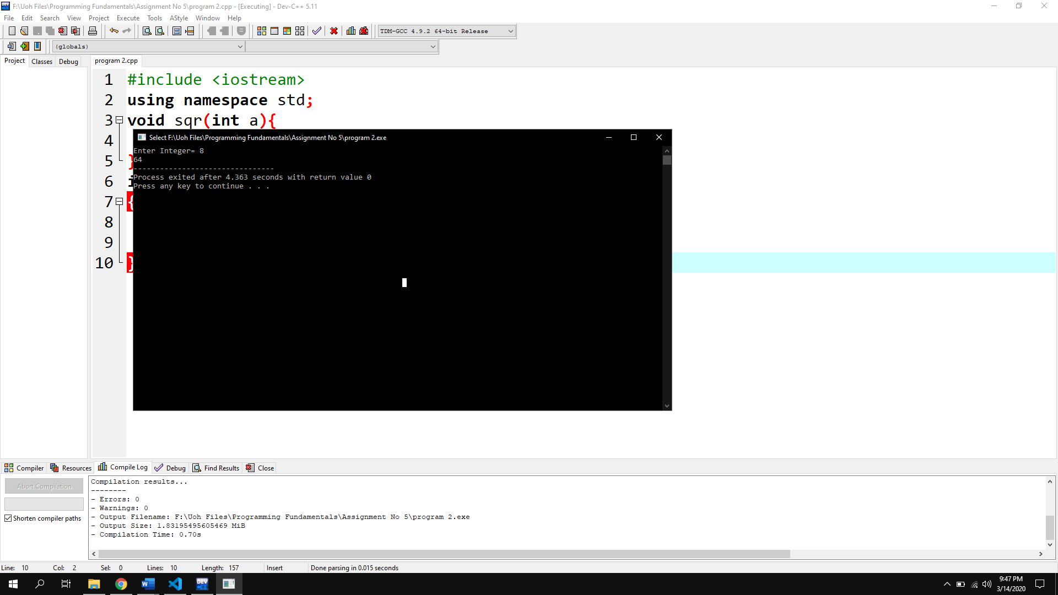

Program No 3:

|  |
| --- |
| #include <iostream>  using namespace std;  void average1(float a,float b, float c){  float sum=a+b+c;  float ave=(sum*100)/300;  cout<<ave<<"%";}  int main()  { float a,b,c;  cout<<"Enter three numbers for Average= ";cin>>a>>b>>c;  average1(a,b,c);} |

Output:

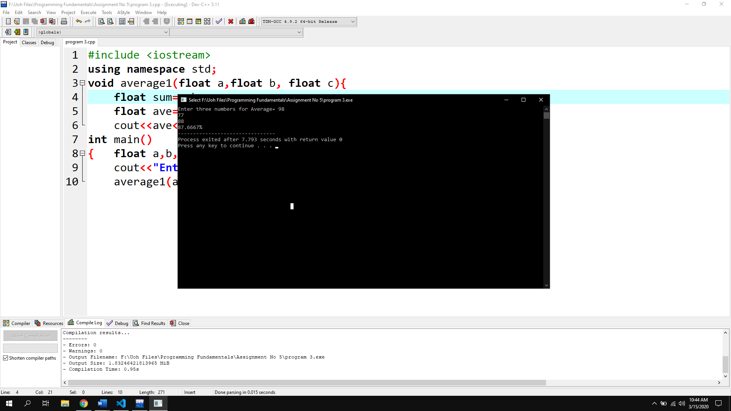

Program No 4:

|  |
| --- |
| #include <iostream>  using namespace std;  int cube(int n)  {return n*n*n;}  int main()  { int r;  do{int n;  cout<<"Input a number= ";cin>>n;  cube(n);  cout<<cube(n);  cout<<"\nEnter 0 to terminate program= ";cin>>r;  } while (r!=0);} |

Output:

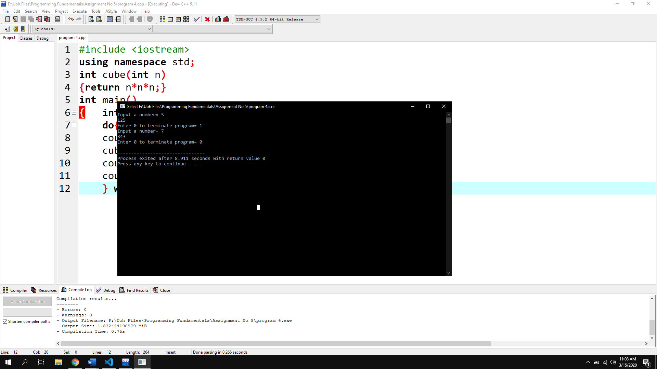

Program No 5:

|  |
| --- |
| #include <iostream>  using namespace std;  int average(int l,int w)  {return l*w;}  int main()  { int l,w;  cout<<"Input length= ";cin>>l;  cout<<"Input Width= ";cin>>w;  cout<<"average= "<<average(l,w);} |

Output:

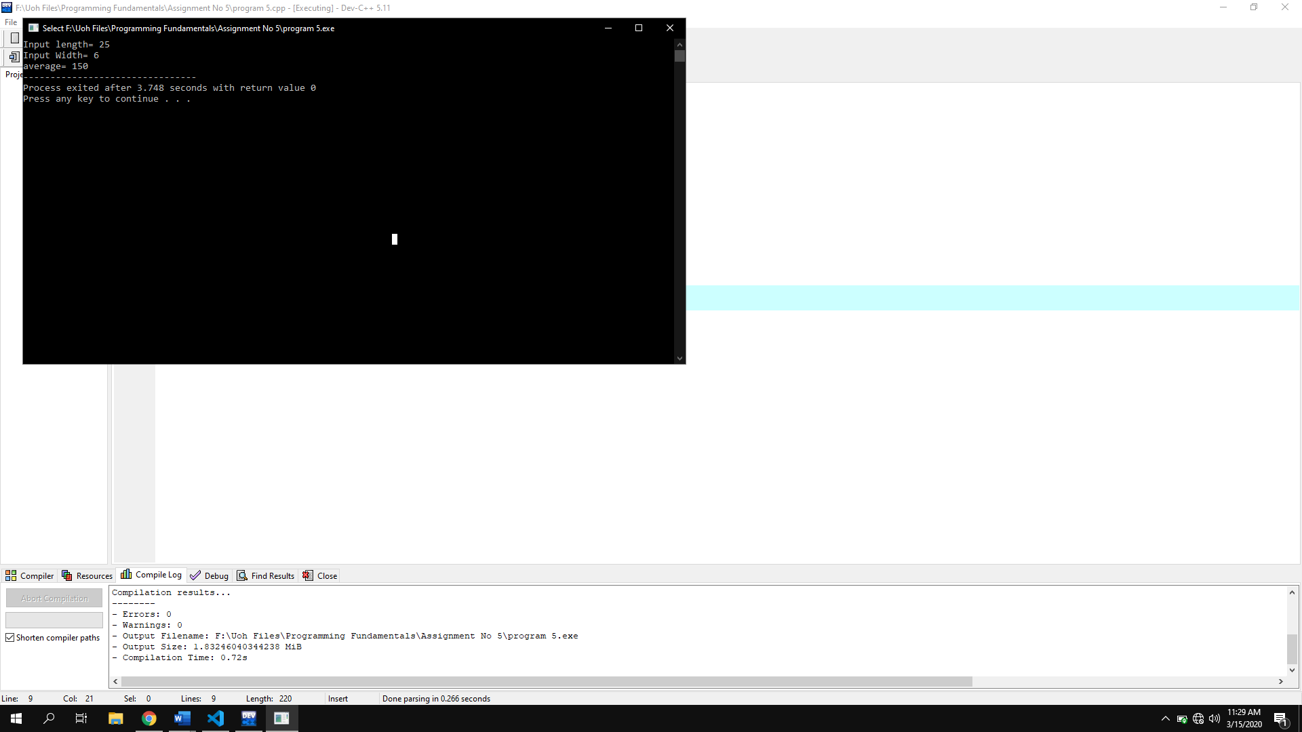

Program No 6:

|  |
| --- |
| #include <iostream>  using namespace std;  void printdate(int day=0,int month=0,int year=0)  { int termi;  do{  int day,month,year;  char select;  cout<<"Enter Day= ";  cin>>day;  cout<<"\nEnter Month= ";  cin>>month;  cout<<"\nEnter year= ";  cin>>year;  if (day>=1 && day<=31 && month>0 && month<13 && year>0)  {  cout<<"Enter d for Day/Month/Year\nEnter m for Month/Day/Year\nEnter y for Year/Month/Day= ";  cin>>select;  switch (select)  {  case 'd':  cout<<day<<" / "<<month<<" / "<<year;  break;  case 'm':  cout<<month<<" / "<<day<<" / "<<year;  break;  case 'y':  cout<<year<<" / "<<month<<" / "<<day;  break;    default:  cout<<"You entered invalid character!";  break;  }  }  else  {  cout<<"You Entered invalid Date";  }  cout<<"\nEnter 0 for termination= ";  cin>>termi;  }while (termi!=0);  }  int main()  {  printdate();  } |

Output:

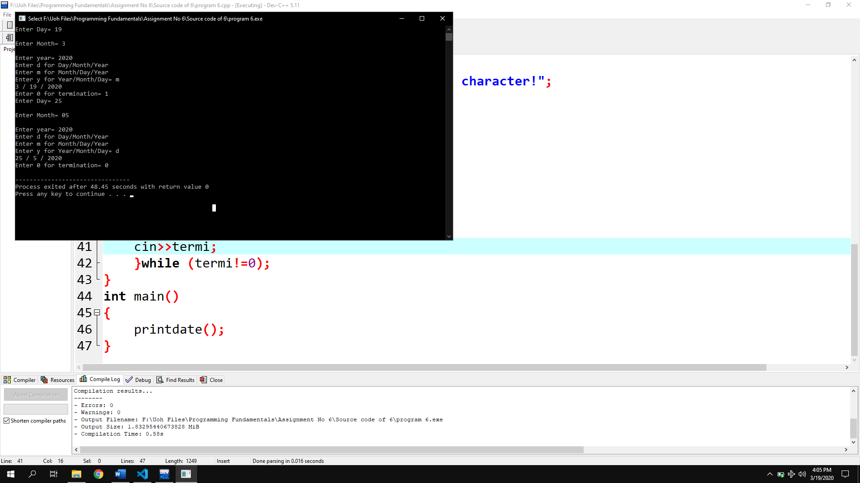

Program No 7:

|  |
| --- |
| #include <iostream>  using namespace std;  bool isleapyear(int year=0)  { int terim;  do  {  cout<<"Enter year to check= ";  cin>>year;  if(year%100==0)  {  if (year%400==0)  {  cout<<year<<" is a leap year";  }  else  {  cout<<year<<" is not leap year";  }    }  else if (year%400)  {  cout<<year<<" is a leap year";  }  else  {  cout<<year<<" is not leap year";  }    cout<<"\nEnter 0 to terminate program= ";  cin>>terim;  } while (terim!=0);  return year;  }  int main()  {  cout<<isleapyear();    } |

Output:

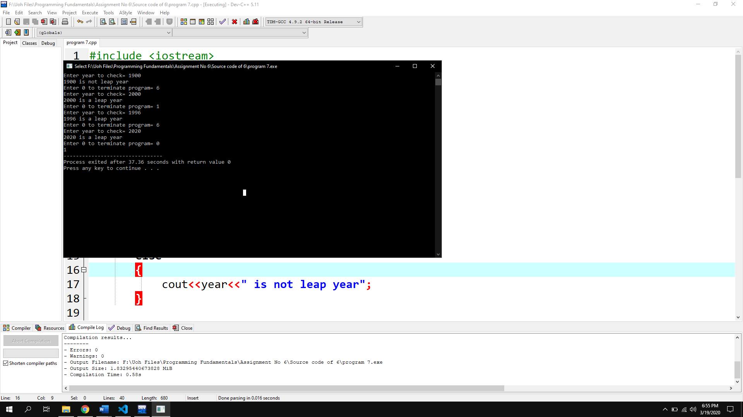

Program No 8:

|  |
| --- |
| #include <iostream>  using namespace std;  void tocheck(int a,int b)  {  if(a==b)  {  cout<<"A B are the same";  }  else if(a<b)  {  if(a!=b){  cout<<"A & B are not same";  cout<<"\nA is less than B";  }}  else  {  cout<<"A is Greater than B";  }  }  int main()  {  int a,b;  cout<<"Enter value of A= ";  cin>>a;  cout<<"\nEnter value of B= ";  cin>>b;  tocheck(a,b);  } |

Output:

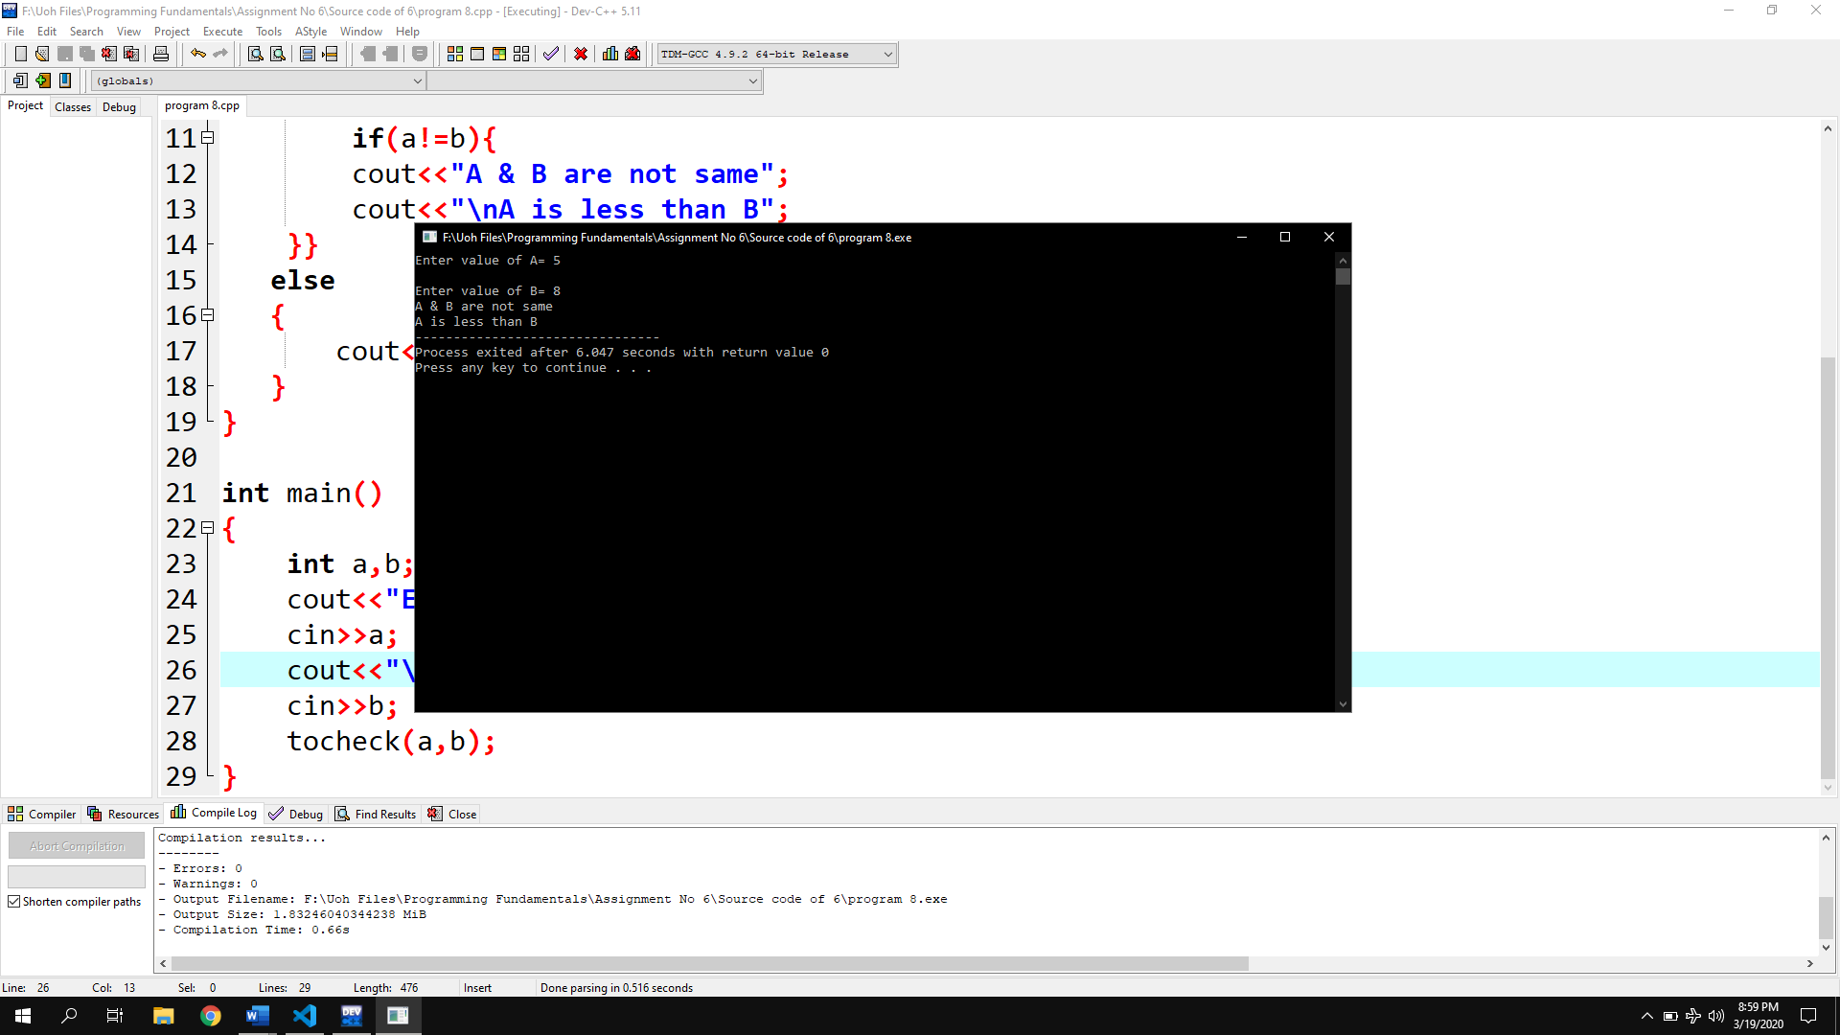

Program No 9:

|  |
| --- |
| #include <iostream>  using namespace std;  void printTempOpinion(int temp)  {  if(temp<=10)  {  cout<<"COLD";  }  else if(temp>=20 && temp<=30)  {  cout<<"OK";  }  else if(temp>30)  {  cout<<"HOT";  }    }  int main()  {  int checktep;  cout<<"Enter temperature= ";  cin>>checktep;  printTempOpinion(checktep);  } |

Output:

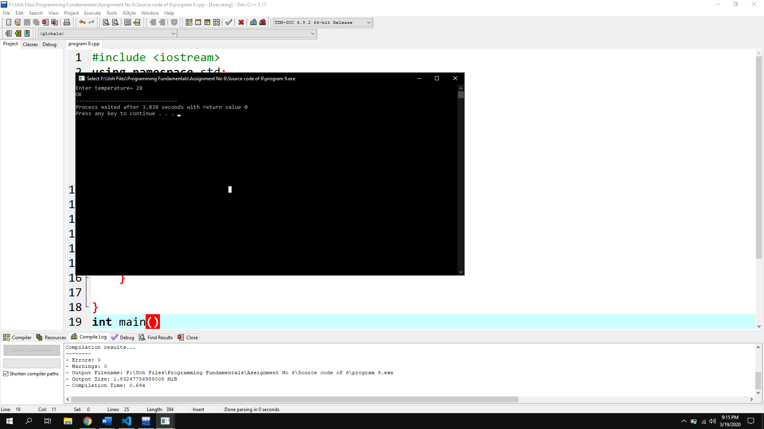

Comparison of functions

Difference between Passing By Value Versus Passing By Reference

|  |  |
| --- | --- |
| By value | By Refrence |
| While calling a function, we pass values of variables to it. Such functions are known as “Call By Values”. | While calling a function, instead of passing the values of variables, we pass address of variables(location of variables) to the function known as “Call By References. |
| In this method, the value of each variable in calling function is copied into corresponding dummy variables of the called function. | In this method, the address of actual variables in the calling function are copied into the dummy variables of the called function. |
| With this method, the changes made to the dummy variables in the called function have no effect on the values of actual variables in the calling function. | With this method, using addresses we would have an access to the actual variables and hence we would be able to manipulate them. |
| Program:  #include <iostream>  using namespace std;  void swapNum(int n)  {    n+=10;    cout<<n;  }  int main()  {    int n;    n=10;    cout<<n<<endl;    swapNum(n);    cout<<"\nAfter function= ";    cout<<n;  }  Output:  10  20  After function= 10 | Program:  #include <iostream>  using namespace std;  void swapNum(int &n)  {    n+=10;    cout<<n;  }  int main()  {    int n;    n=10;    cout<<n<<endl;    swapNum(n);    cout<<"\nAfter function= ";    cout<<n;  }  Output:  10  20  After function= 20 |

Program No 10:

|  |
| --- |
| #include <iostream>  using namespace std;  void swapNum(int &a,int &b)  {  a=44.4;  b=22.2;  }  int main()  {  int a=22.2;  int b=44.4;  cout<<"a= "<<a<<endl;  cout<<"b= "<<b<<endl;  swapNum(a,b);  cout<<"----After funvtion----"<<endl;  cout<<"a= "<<a<<endl;  cout<<"b= "<<b;  } |

Output:

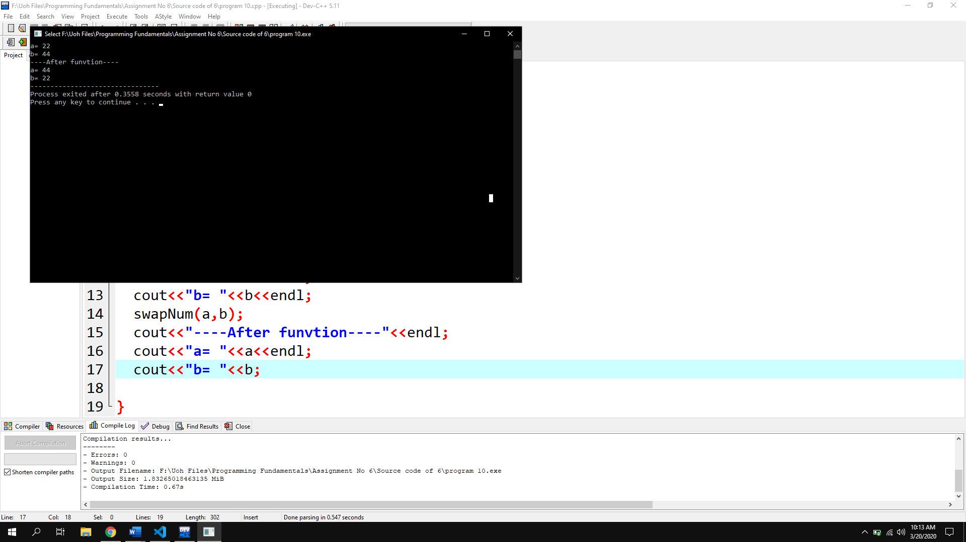

Program No 11:

|  |
| --- |
| #include <iostream>  using namespace std;  int plusFunc(int x, int y) {  return x + y;  }  double plusFunc(double x, double y) {  return x + y;  }  int main() {  int myNum1 = plusFunc(8, 5);  double myNum2 = plusFunc(4.3, 6.26);  cout << "Int: " << myNum1 << "\n";  cout << "Double: " << myNum2;  return 0;  } |

Output:

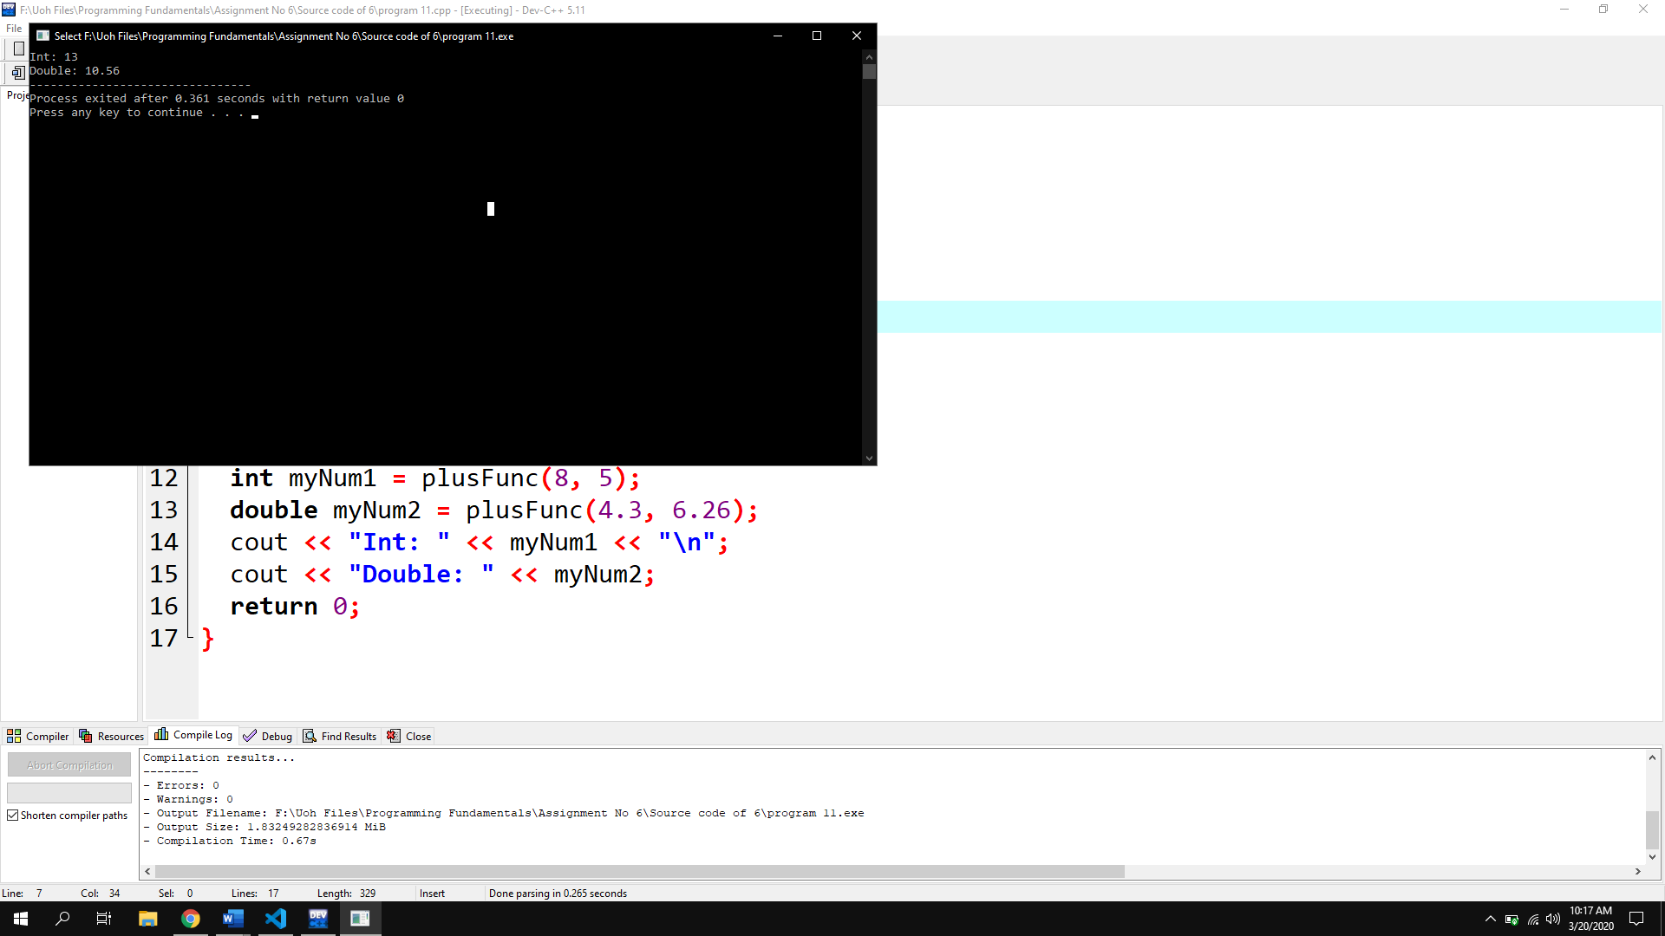

Program No 12:

|  |
| --- |
| #include <iostream>  using namespace std;  void factorial()  {  int f;  for (int n = 1; n < 11; n++)  {  int f=1;  for(int j=1;j<=n;j++)  {    f=f*j;  }  cout<<"Factorial of "<<n<<"="<<f<<endl;  }  }  int main()  {  factorial();  } |

Output:

